

Assessment Cover Page
Student Full Name | Thaninnada Samart
Student Number | 2026781
Module Title | Machine Learning
Assessment Title | CA 1 – Machine Learning
Lecturer/Supervisor | Dr. Muhammad Iqbal
Assessment Due Date | Sunday 15th November 2026
Date of Submission | Sunday 15th November 2026
GitHub Link | https://github.com/thaninnada/CA1_Machine_Learning_Sep2026

Use of AI Tools
I acknowledge the use of Codex to assist in the execution of this project. Codex was employed to develop workflows based on the assigned tasks and to support technical work, including debugging and code explanation. I affirm that I remain solely responsible for the project content, the interpretation of results, data analysis, and all final decision.
Declaration
By submitting this assessment, I confirm that I have read the CCT policy on academic misconduct and understand the implications of submitting work that is not my own or does not appropriately reference material taken from a third party or other source.
I declare it to be my own work and that all material from third parties has been appropriately referenced.
I further confirm that this work has not previously been submitted for assessment by myself or someone else in CCT College Dublin or any other higher education institution.

- Introduction and Motivation
- Problem Domain and Research Objectives
- Dataset Characterization
- Data Pre-processing
- Explanation of at least 2 ML Models
- Accuracy comparison across 3 Splits
- Cross-validation results
- Hyperparameter Tuning and GridSearchCV
- Best Parameters and Accuracy
- Model Comparison and Interpretation
- Overfitting, Underfitting and Generalisation
- Conclusion
- References

Use of Artificial Intelligence
This assessment applies the AI Fluency Framework — four interconnected competencies for effective, efficient, ethical and safe AI use. Your engagement with AI will be reviewed across all four dimensions:
Delegation  Setting goals and deciding whether, when and how to engage with AI. | Description  Effectively describing goals to prompt useful AI behaviours and outputs.
Discernment  Accurately assessing the usefulness of AI outputs and behaviours. | Diligence  Taking responsibility for what we do with AI and how we do it.

AI Declaration using the AI Fluency Framework
AI competence | Reflective prompts (to students) | Lecturer expectations | Student response
Delegation  Deciding whether & when to use AI | Identify the specific tasks in this assessment where you chose to use AI, and explain your reasoning. Where did AI add value? Where did you decide not to use it, and why? | For this assessment, Generative AI may be used only as a supporting tool for brainstorming and refining ideas, fine-tuning research questions, finding relevant information, drafting an outline, checking grammar, clarity and writing style, and other uses explicitly approved by the lecturer.  These uses support planning, research and communication. GenAI must not replace the student's own technical implementation, analysis, modelling, evaluation or interpretation, as these directly assess the learning outcomes. You may not copy and paste GenAI output in your submission. All GenAI use must be declared in the GenAI Tools Declaration (Appendix A). | [Student response]
Description  How you prompted the AI | Include the exact prompts you used in your appendix (recorded on the AI Tools declaration). Reflect on how you communicated your goals to the AI — did you need to iterate or refine your prompts to get useful output? | Students must provide evidence of prompting for all permitted GenAI use. The exact prompts used, together with relevant links, screenshots or evidence of prompt refinement where applicable, must be provided in Appendix B. Failure to do so is considered to be academic misconduct. | [Student response]
Discernment  Evaluating what the AI produced | In your reflection (~100 words), critically evaluate the AI output: what did you accept, modify, or reject — and why? Assess accuracy, relevance, and quality. You are responsible for verifying all AI-generated content before submitting. | A reflection is required for this assessment. In approximately 100 words, students must critically evaluate the accuracy, relevance and quality of any GenAI-assisted outputs, explaining what they accepted, modified or rejected and why. Failure to do so is considered to be academic misconduct. | [Student response]
Diligence  Responsibility for your AI use | Declare all AI tools used and cite them here. Briefly outline (~100 words) how you considered data protection, copyright, and ethical responsibilities when choosing what to input into any AI system. Unauthorised use is subject to CCT disciplinary procedures. | Students must declare all GenAI tools used and cite them appropriately. In approximately 100 words, students must explain how they considered data protection, copyright and ethical responsibilities when using GenAI. Unauthorised GenAI use is subject to CCT disciplinary procedures. Failure to do so is considered to be academic misconduct. | [Student response]
When using AI tools, students must consider data protection, privacy, and copyright. Do not upload personal data or third-party material without appropriate permissions. See EU Data Protection, EDPS Orientations on GenAI, and UNESCO Guidance: AI in Education &

Appendix B
- I used prompts in Codex to fuses support planning for my project . This is prompt I use in this project Create a Data Preparation CA1 workflow based on the assignment brief [@flie HDIP_DPrep_CA1_V9 ], following a sequence that ranges from inspecting the dataset to evaluating the results after dimensionality reduction.” and the image below show the actual results with prompt. 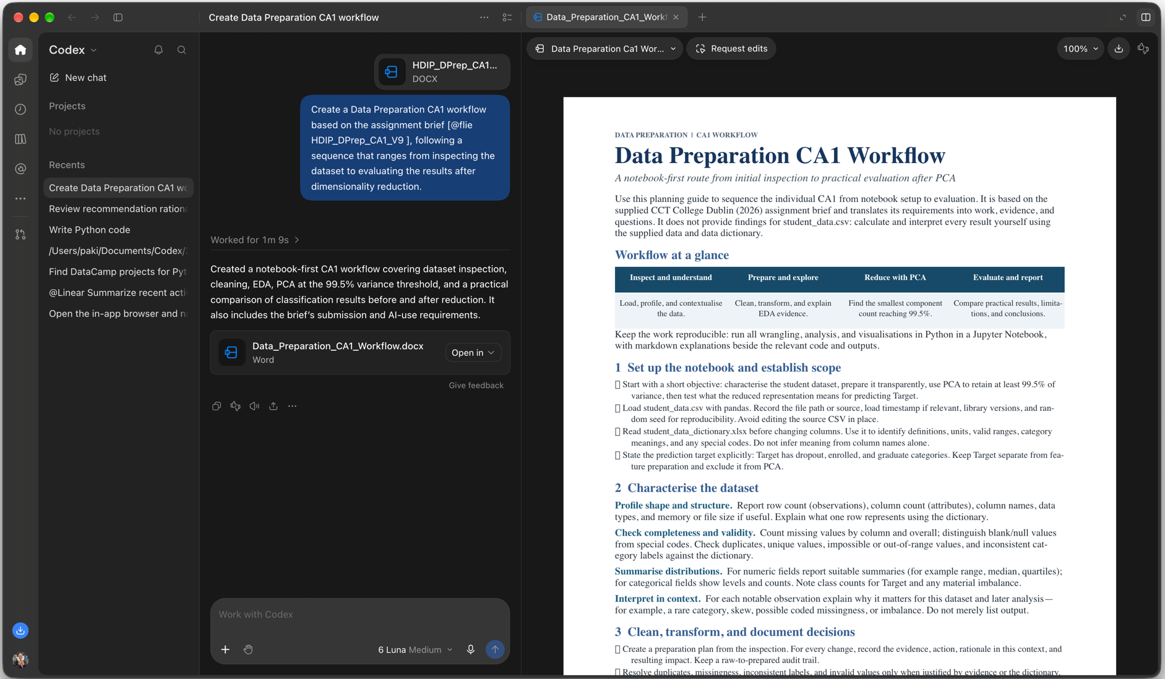
- I used prompts in Codex “ You are a senior Python developer and data analytics specialist. Help me debug, review, and improve Python code for my Data Analytics coursework.”


